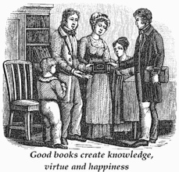
基督教文化产业 摘自《诗祭千秋》
传扬福音
6月25日 英国牧师、作家、诗人巴斯克（1615-1691）

主呼召我趁着白昼出去做工，
警告可怜的灵魂转回切莫迟延；
决心尽快去传播主的道，
随学随教导同安波罗修一般。
时时想到我不能活得长久，
心中火热为得人灵魂争战。
我讲道，不缺纸是否能再讲，
像将死的人传给将死的人！
啊，传道者该如何切望得人悔改，
谁知道教堂与墓园原是比邻？
看到人在传讲，在听，在死亡，
转眼从时间进入无尽的永恒！

理查.巴斯克牧师是英国牧师及作家。曾任克伦威尔军牧。英王查理二世复辟后，曾因非国教立场而数次入狱。

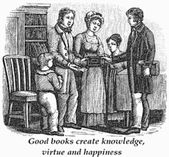
Christians Christian Cultural Heritage
Preaching the Gospel
25 June 2023 extracted from Poems and Hymns
by English author, hymn writter, preacher Richard baxter (1615-1691)

Thou called me out to work while it was day,
And warn poor souls to turn without delay;
Resolving speedily thy Word to preach,
with Ambrose I at once did learn and teach.
Still thinking I had little time to live,
My fervent heart to win men’s souls did strive.
I preach as never sure to preach again,
and as a dying man to dying men!
O how should preachers men’s repenting crave
Who see how near the Church is to the grave?
And see that while we preach and hear, we die,
Rapt by swift time to vast eternity!

Richard Baxter (1615–1691) was an English Puritan church leader, poet, hymn-writer, theologian, and controversialist. He was well known for his pastoral ministry in Kidderminster, from which he wrote the book “The Reformed Pastor”, which has become our church’s pastoral handbook.

