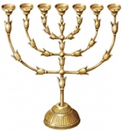 | 为何我们不庆祝 复活节  摘自赖准夺牧师2009年“牧者的话”

下主日就是所谓的Easter（复活节）；在受基督教影响的地区通常在受难节之后的星期日或星期一就是‘复活节’(Easter)，但是这个纪念日我们不主张去遵守，本文在这方面给予解释。
‘复活节’是最古老的节日之一，在主受难以前就有了。根据农作历法是春分月圆后的第一个星期日，如果月圆那天刚好是星期天，复活节则推迟一星期，所以复活节可能在3月22日至4月25日之间的任何一天； 目前西方世界是根据天主教的计算法。
首先，在《圣经》里主耶稣只是教导我们记念祂的死，从来没有说记念主的复活。《路加福音》22:19-20就是一个例证：「又拿起饼来祝谢了，就掰开递给他们，说，这是我的身体，为你们舍的。你们也应当如此行，为的是记念我。饭后也照样拿起杯来，说，这杯是用我血所立的新约，是为你们流出来的。」
其次，这个节日有浓厚的异教传统。它是古代异教的“春节”，是庆祝春回大地的节日，源于古巴比伦的爱情、生育与战争女神伊丝塔（Ishtar）——美索不达米亚(Mesopotamia)的女神，后来伊丝塔成了西欧的黎明和春天女神 “依丝翠(Eastre)”。显然Easter是个名字，源自迦勒底（巴比伦），Easter其实就是“阿斯塔特(Ashtart)”，即他们的‘天后’，考古学家在碑铭上发现证实这就是古巴比伦的生育和战争女神’。
还有，罗马帝国君士坦丁大帝在公元325年召开第一次尼西亚公会议，订明了复活节是星期日。在教会历史上这个日子曾经是在喋喋不休的争辩中，可是主复活在《圣经》已经清楚的记载，对圣徒而言无论有一个‘复活节’吗根本无济于事，更何况主耶稣要再来。这种订下一个‘日子’的政治作为（包括圣诞节）是没有太大的属灵价值，但是圣徒确知主复活了、升天了、要再来……这些才是宝贵的！
更要小心的是，在西方与复活节相关的物品有复活节兔和复活节彩蛋等。传说复活节彩蛋都是兔子的蛋（但事实上，兔子其实是不下蛋的，复活节彩蛋都是鸡蛋），有些人喜欢在蛋上画各种各样的鬼脸或花纹。而这些民间风俗都是非圣经的，如果我们轻易的接纳了就像《诗篇》107:27说的：“ 他们摇摇幌幌、东倒西歪、好像醉酒的人、他们的智慧无法可施。”我们千万不要在这个主日送彩蛋，也不要在儿童主日学给他们画彩蛋。彩蛋是一项有意思的手工，我们宁可在其他的时候举行，避免幼小的心灵被非圣经的西方风俗习惯所腐蚀。
我们在新约时代已经不需要遵守旧约的许多‘节期’了，在两千年的教会历史中也产生了不少的新的节期，我们认为只有受难节与圣诞节有记念的意义（但不是遵守）；这两个少不了与异教有些关联，但是我们不需要将之用三拜五跪来搞成一个煞有其事的宗教节日，我们乃是取其意义来作见证、传福音就足够了。这是我们浸信精神的精义，所以我们没有追随所谓的‘圣枝主日’(Palm Sunday)等等的改革宗传统，我们刻意的回到圣经。
因此圣诞节给我们一个良机向仰慕主道的人们再次宣告基督降世的目的，受难节给那些不信者无法抹杀基督受难为罪人的史实；世人看这是宗教节日，我们不要附庸之，乃是要从中争取机会作出美好的见证。
怎么样才能好好使用受难节与圣诞节呢？首先要避开世俗性的东西，比如在圣诞节我们不需交换礼物，受难节我们不需以烛光把气氛弄得凄凉，我们单单就以《圣经》的内容、圣诗歌等加上简短的证道信息就行了，让神道去作工就是。
这两个节期上世俗的消费品也很多，从卡片到CD等林林总总，圣徒不要为着节期去消费，反之把金钱奉献在广传福音的圣工上。凡事都是「务要谨守，儆醒。」（彼前5:8）我们不需要去批评那些庆祝‘复活节’的基督徒，为他们祷告就是，有机会就不妨提醒他们；许多时候许多事情都是在不知不觉中做了，被提醒了转回头就是了。
记得，我们也不是去庆祝受难节，乃是去记念基督受难；我们不是庆祝圣诞节，乃是去记念耶稣基督降世。

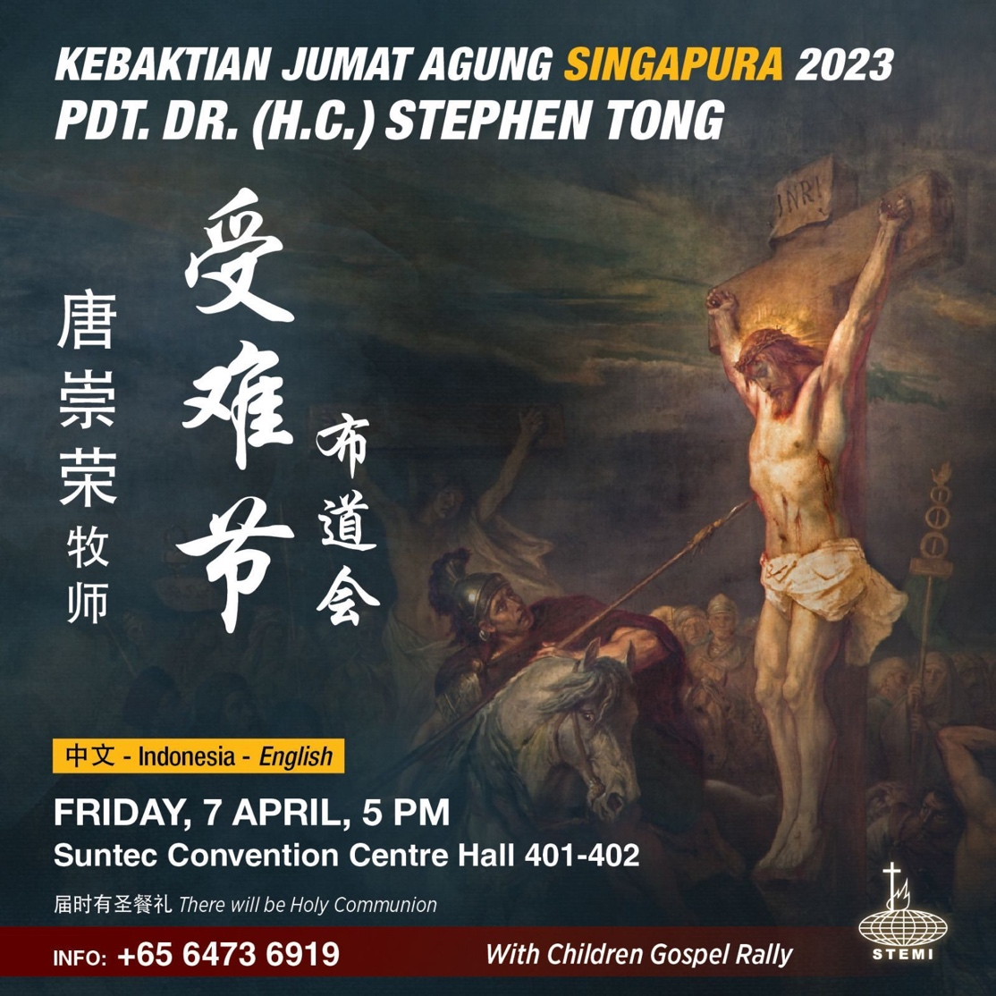

Examining issues together with your pastor
Why We Do Not Celebrate Easter
Taken from Reverend Lai’s desk notes in 2009 Translated by Li Yixing

There are many important teachings that need to be repeated year after year. “Why we do not celebrate Easter” is one of them. This is because many Christians are still following the Easter traditions such as the Easter rabbit and the Easter eggs today. Just as the aged Apostle Peter solemnly declared, “So I will always remind you of these things, even though you know them and are firmly established in the truth you now have … I will make every effort to see that after my departure you will always be able to remember these things.” (2Peter 1:12-14). Therefore I must share with you this precious writing from our beloved Rev. Lai’s legacy again. May the Holy Spirit establish your faith firmly on the truth of God.
Rev. Zheng 2 April 2023

Many brothers and sisters have asked me: “Should we celebrate Easter, since some churches do?” Let me take this opportunity to clarify the biblical teachings on this issue.
Tomorrow is Easter. In regions under Christian influence, the Sunday or Monday following Good Friday is usually designated as “Easter”; however, we do not encourage its observation, and this article explains why.
“Easter” is one of the most ancient festivals, and it existed before the Lord’s crucifixion. According to the lunar calendar, it falls on the first Sunday after the first full moon after vernal equinox; if the full moon happens to occur on a Sunday, Easter will be postponed for a week. Hence, Easter can fall on any day between 22 March and 25 April; currently, the Western world follows the calculation of the Roman Catholic Church.
Firstly, in the Bible, the Lord Jesus had instructed us only to remember His death, but never His resurrection. For instance, Luke 22:19-20: “And he took bread, gave thanks and broke it, and gave it to them, saying, ‘This is my body given for you; do this in remembrance of me.’ In the same way, after the supper he took the cup, saying, ‘This cup is the new covenant in my blood, which is poured out for you.’ ”
Secondly, this festival has a rich pagan tradition. It is the “spring festival” of ancient paganisms, a festival to celebrate the return of spring to the land. It originated from Ishtar, the Babylonian goddess of romance, fertility and war-- the goddess of Mesopotamia, who later became Eastern Europe’s goddess of dawn and spring, known as “Eastre”. Clearly, “Easter” is a name with origins from Chaldeans (Babylon), and it is equivalent to “Ashtart”, their “heavenly queen”. Archaeologists have found evidence from inscriptions that she is the goddess of fertility and war in ancient Babylon.

Emperor Constantine of the Roman Empire had held the First Council of Nicaea in 325 B.C., officially designating Easter as a Sunday. Despite the relentless debate over “Easter” in church history, since the Resurrection has been clearly recorded in the Bible, whether there is an “Easter” is inconsequential to saints. Moreover, Lord Jesus will come again. The political act of designating a “day” (including Christmas) has little spiritual value. On the contrary, for saints to clearly know that the Lord has Resurrected, Ascended and will come again…that is precious!

Further caution should be taken towards the objects that are frequently associated with Easter in the West, such as the Easter bunny and Easter eggs. Legend has it that Easter eggs are bunny eggs (in fact, bunnies do not lay eggs and Easter eggs are actually from chickens), and some enjoy painting various faces and patterns on the eggs. These folk practices are not Biblical, and if we accept them easily, we will be like what has been described in Psalms 107:27: “They reeled and staggered like drunkards; they were at their wits’ end.” We must not give Easter eggs as presents on this Lord’s Day, or let children paint Easter eggs during Sunday school. Painting eggs is in itself an interesting handicraft, but we would rather conduct it at other times to prevent non-Biblical practices from corroding our young minds.

Under the New Testament, we no longer need to observe the numerous festivals of the Old Testament; throughout two thousand years of church history, many new festivals were born as well. We believe that it is meaningful to commemorate only Good Friday and Christmas (but not to observe); these two festivals are inevitably linked to paganisms, but we do not need to turn them into cumbersome religious ceremonies; it is sufficient if we utilize their significance to testify and evangelize. This is the essence of our Baptist spirit. Hence we do not follow Reformed traditions such as Palm Sunday; instead we consciously return to the Bible.
Therefore, Christmas gives us a great opportunity to proclaim the purpose of Christ’s birth to those who seek the gospel; Good Friday presents to non-believers the historical truth of Christ’s crucifixion for sinners. The world sees these as religious festivals; we should not follow the flow, but rather seek opportunities to be good witnesses for God.
How do we make good use of Good Friday and Christmas? Firstly, avoid worldly practices: for example, we do not need to exchange gifts during Christmas, or use candlelight to create a melancholic atmosphere on Good Friday. All we need is the Bible, hymns and a brief sermon, and we let God’s word do the work.
Secular consumer goods are also abundant during these two festivals, ranging from cards to CDs, etc. Saints should not splurge during the festivals, but rather offer our wealth for the holy work of evangelism. In everything we must “be alert and of sober mind” (1Peter 5:8). We do not have to criticize Christians who celebrate “Easter”; we can pray for them and remind them when there is a chance. Often we do things unknowingly, but we can always turn back when reminded.
Remember, we do not “celebrate” Good Friday, but rather remember Christ’s crucifixion; we do not “celebrate” Christmas, but rather remember the birth of Jesus Christ.

